PRODUCT DEMO APP

Content
- Introduction
- App Flow
- Code Design
- Glossary

INTRODUCTION
A product sale app demo where its purpose is to display current available product from the server and allow the user to view and make reference on the product. The user can search by typing or by using tag to filter. The design is aim to be user friendly along with flexible adaptability with the global function (For user preference).

APP FLOW
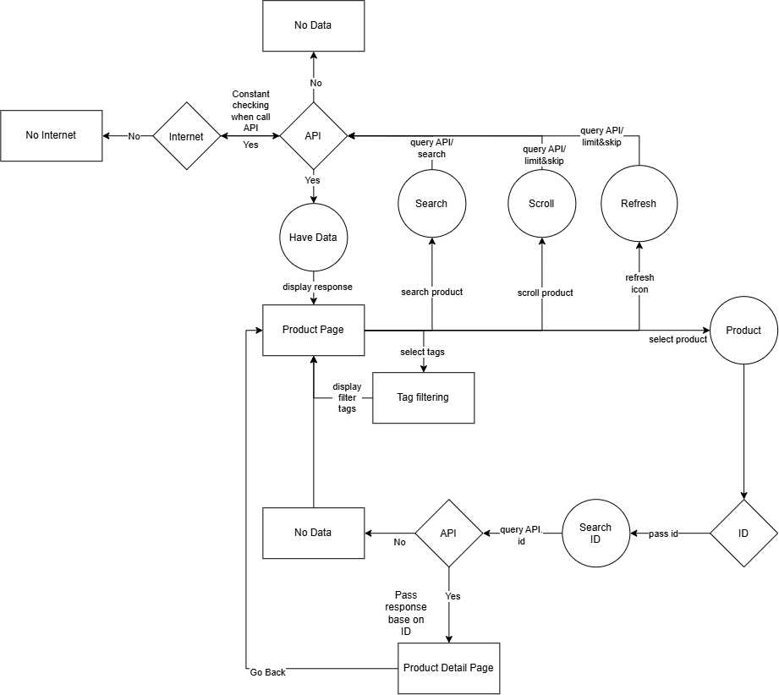

The flow above shows the entire app loop cycle from opening the app until viewing the product detail. Below is the key detail for each process.
- All API response must check internet availability
- Scrolling and refresh all trigger similar API. The different is that scrolling add the next batch into the list.
- Tags does not new API, it uses pre-existing API and fetch only the title of the product.
- Product detail page fetch API base on ID.
- If there is ‘No data’, it means API response wrong or the item have no data.

CODE DESIGN
- Using Flutter 3.41.1 and dart version dart 3.11
- Draw.io (For flow diagram)
- Android emulator (For visual feedback)
- Code structure
  - 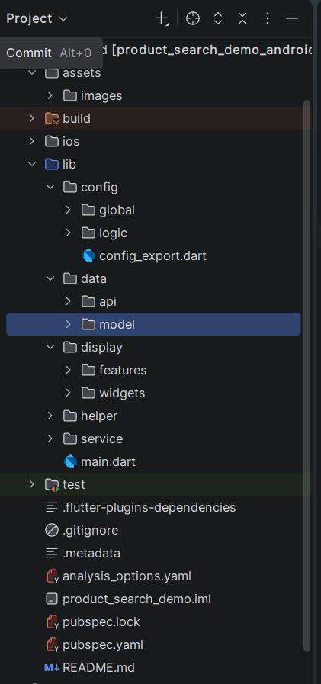
- Inline documentation (Comment)
  - Sample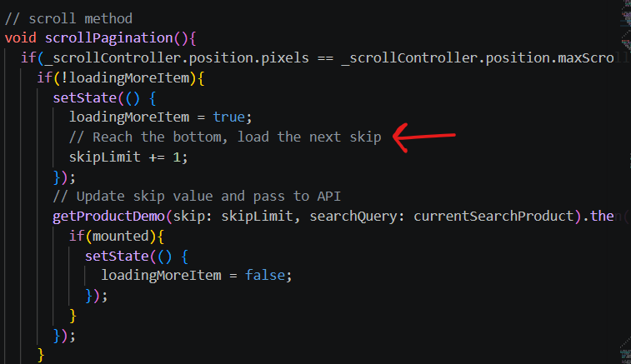
- Mechanics
  - Load Page
    - Call API https://dummyjson.com/products
      - Hardcode parameter for item skip = 0
      - Global parameter set for item limit = set to 30
    - Loading circle (Wait for data to load)
  - Search
    - Call API https://dummyjson.com/products/search
      - Use https://dummyjson.com/products to fetch all the product then temporarily store the title of the product.
      - User is force to select the title and pass the title as {q = product title selected}
    - App load and display selected product.
  - Tags
    - Hardcode all the tags into separate class as reference.
    - Add the dialog box to display all the tags and user can select multiple tags.
    - Base on this API (and the next following item limit) https://dummyjson.com/products?limit=20&skip=0, the tag will filter it from the tags query and display the tagged product.
  - Display product
    - From https://dummyjson.com/products?limit=20&skip=0 and subsequent skip limit, it will fetch the length (total) and display into a 2x2 grid view by order receive from API. (No sorting in app).
    - When reach the limit of the first batch (Currently at 30), the next 30 batch of item will load from API, adding into the previous loaded batch.
    - Each product item is clickable and once click, it will capture the id of the product and move to Product Detail Page.
  - Product detail page
    - View selected product using the item stored from selecting item on the previous page and call the API https://dummyjson.com/products/{id}.
    - Display image in a side scrolling if have multiple images.
    - Display selected product detail (Title, Rating with icon, price, description, and reviews)
    - Reviews are build using a List Tile Builder and uses reviews length to display all the reviews.

GLOSARY
App screenshot
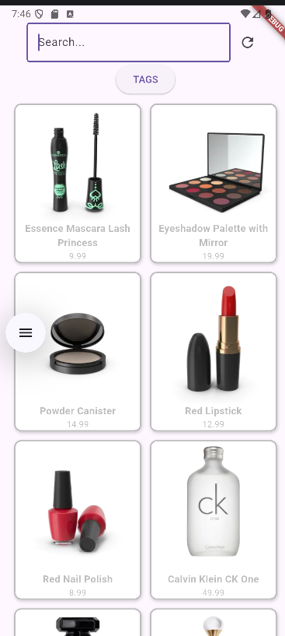 | 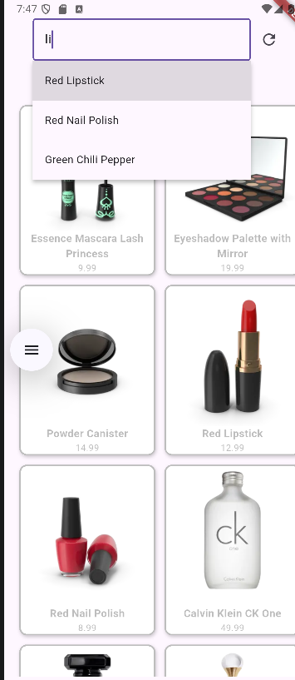
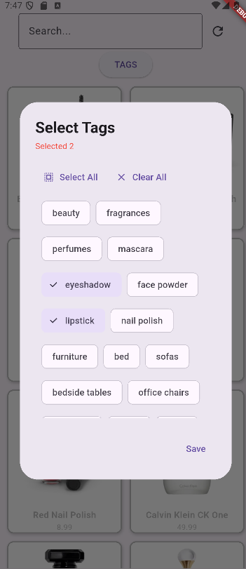 | 